**New Quality Control Chart to Quickly Detect the Changes of Process Average**

**Abstract**

The intention of this article is to propose a new control chart—improved exponentially weighted moving average (IEWMA) control chart—to fast detect the mean shifts of process when data are normally distributed. The efficiency inspection of IEWMA control chart is managed 504 situations for the simulation data. Moreover, the four control charts, namely, exponentially weighted moving average (EWMA), robust exponentially weighted moving average (REWMA), median mean absolute deviation (MDMAD), and average control charts, are compared the performances with IEWMA control chart. All charts are constructed by using data set in two cases, i.e., the first case that data are not include outliers and the second case that data are composed of outliers. It is found that in the case of non-outliers in the data, the three charts—IEWMA, EWMA and REWMA control charts—tend to have the most capability for process average shift detection for all sample sizes and all levels of the process average changes. For the case of outliers in the data, the IEWMA control chart tends to have the most efficiency for all sample sizes, especially for the tiny process shifts from the target.

***Keywords***: control chart, exponentially weight, moving average, normal distribution, outliers, process mean

1. Introduction

Generally, qualities of the manufactured products in industrial production process are required to achieve or overcome the customer expectations. Moreover, the fundamental goals of production are to achieve the target mean of the process and to control the variation of product quality to be minimum level. The variation of industrial production process can be occurred all the time, no matter how the production process well designed or controlled. This variation is influenced by various factors that both controllable and uncontrollable factors, for example, it may be caused by using non-standard tools or using the wrong types of tools, the machine may deteriorate, the workers do not have production skills, the qualities of raw materials in the production process are lower qualities than specified levels, etc. These factors will affect the product quality. That is, if products in the production process have a small variation, it will result in the quality of each manufactured product being not much different quality. However, if products in the production process have a large variation, it will affect the product quality that does not achieve the product standards. In the industrial production process often encounter problems that products that do not meet the specified standards. One of the main reasons is the process average to be controlled has changed, but the process operators may be unaware of this change. Thus, if they allow production to continue resulting in non-standard products coming out of the process. These problems have the detrimental effect on the factory which may experience loss or damage the reputation of the factory when those inferior products are distributed to the consumers. The quality control chart is one of the most popular tools for statistical process control to warn the manufacturers that the current production process has changed from a predetermined one. This makes it possible to quickly resolve quality issues when manufacturing malfunctions occur. If the chart is regularly analyzed in the production process, it helps to ensure consistent product quality and reduce variation in the manufacturing process. The idea of statistical control chart was first introduced by Shewhart (Montgomery, 2012), e.g., average control chart was devised under the assumption that data are normally distributed. This average control chart is generally utilized in quality control processes because it is easy to understand by the operators and it is not a complicated tool. However, several researches are shown that the average control chart is poor effective tool to detect abnormal process in cases of the small process mean shifts from the target (Abu-Shawiesh, 2009; Wang, 2009; Huang, Tai and Lu, 2014; Chew *et al.*, 2015). After that, there are many fast response control charts that to be better than the average control chart for detection the slight mean shifts were proposed as follows: in 1959, the exponentially weighted moving average control chart or EWMA control chart was proposed by using the weighted mean of all past and current observations for monitoring the process (Roberts, 2000). Therefore, this chart is very effective for the slight process shifts (Lucas and Saccucci, 1990; Knoth, 2005; Khoo and Sim, 2006; Montgomery, 2012; Shamsuzzaman and Wu, 2012; Şentürk *et al.*, 2014; Chakraborti and Graham, 2019; Hesamian, Akbari and Ranjbar, 2019; Mitra, Lee and Chakraborti, 2019). In 1982, cumulative sum control chart was developed by using the property of fast initial response (FIR) and this research was found that it perform well at the outset of the anomalous process (Lucas and Crosier, 1982). Later, the same FIR feature was used to develop EWMA control chart and it has a good performance in detecting of process mean changes for various situations. This control chart is known as the fast initial response exponentially weighted moving average control chart or FIR_EWMA control chart (Lucas and Saccucci, 1990). Furthermore, the adjusted fast initial response value for the FIR_EWMA control chart was introduced and compared its performance with EWMA control chart (Steiner, 1999). This was found that the FIR_EWMA control chart was more effective than the EWMA control chart for detecting the change in process mean from the target at all shifts of process mean. Further, the FIR_EWMA control chart was more effective in detecting variations of the process mean than running sum control chart (Reynolds, 1971; Rigdon and Champ, 1997) and the combined Shewhart-cumulative sum control chart (Lucas, 1982) for all levels of process mean shifts. In 2006, the robust exponentially weighted moving average control chart or REWMA control chart for process average was proposed (Khoo and Sim, 2006). The process standard deviation for construction of the REWMA control chart was estimated by using the quartile range. Then, the results of this study was found that the capability of REWMA control chart performs well under case of data contain outliers (Khoo and Sim, 2006). In 2009, the MDMAD control chart (Abu-Shawiesh, 2009) was proposed by estimating the mean and standard deviation of process with the sample mean and sample median absolute deviation (Hampel, 1974; Rousseeuw and Croux, 1993), respectively. Moreover, the MDMAD control chart has a good performance for outliers in the data collection or data are non-normally distributed. In this study, a new control chart, namely IEWMA control chart, is proposed by using the property of fast initial response and estimating the process mean and process standard deviation with the two robust estimators (Sinsomboonthong, Abu-Shawiesh and Kibria, 2020), namely, sample median and sample median absolute deviation. This proposed control chart is derived for case of the data were normally distributed with outlier ​​occurred. In addition, the performance comparison in term of sensitivity to detect the process mean shifts of the proposed and four control charts—EWMA, REWMA, MDMAD and average control charts—are investigated for 504 data scenarios by simulation study.

# Materials and Methods

In this paper, the efficiency comparison of five control charts for process mean are studied as follows:

## Shewhart Average Control Chart

Shewhart average control chart or average control chart (Montgomery, 2012) is a familiar tool for quality control process. The procedures of control chart construction as follows: let  be a quality characteristic in the process. Suppose a random variable *X* is normally distributed with the mean  and variance. Let  be the random samples of size  that are taken from this process. Hence, the sample mean  is normally distributed with mean  and variance. In case of the process average and the process standard deviation are known, the upper control limit, center line and lower control limit  of the average control chart can be determined in equation (1).

 =  = ,

 =  =  and

 =  =  (1)

 is a constant that defines the control limit width corresponding to the control region (1 *α*) and a required average run length until a false alarm for the in-control process (ARL0) for the average control chart. For example, if a required ARL0 approximates 370 or the control region (1 *α*) equals 0.9973, then the usual three sigma control limits will be constructed and the constant  is equal to 3. In practice, the mean and standard deviation of the process are usually unknown. Then, the upper control limit, center line and lower control limit for the average control chart can be estimated in equation (2).

 = ,

 =  =  =  and

 =  (2)

where  is the sample mean for subgroup *i*. The estimator of the process standard deviation is given by  where, and is the sample standard deviation for subgroup *i*.

## Exponentially Weighted Moving Average Control Chart

Exponentially weighted moving average control chart or EWMA control chart is a good alternative to the Shewhart average control chart for detecting small shifts (Roberts, 2000). For construction of the control limits of EWMA control chart, the assumptions about quality characteristic distribution are the same details as mentioned in section [2.1]. The exponentially weighted moving average at any time *t* or any subgroup *t* can be defined in equation (3).

 =  (3)

where  is a constant and the starting value is the process mean or process target, that is,  where is the average of process quality characteristic to be controlled. The upper control limit (), center line () and lower control limit () for EWMA control chart can be estimated and written in equation (4).

 = ,

 =  =  and

 =  (4)

where is a constant that defines the control limit width corresponding to the control region (1 *α*) and a required ARL0 for EWMA control chart, and  is the sample mean for subgroup . The estimator of the process standard deviation is given by  where, and is the sample standard deviation for subgroup .

## Robust Exponentially Weighted Moving Average Control Chart

The robust exponentially weighted moving average control chart or REWMA control chart was introduced in 2006 (Khoo and Sim, 2006). This control chart developed by using the exponentially weighted moving average = as same as the construction of EWMA control chart. The process standard deviation of this chart was estimated by using the quartile range. Let  be the interquartile range where  and  are denoted statistics of orders  and  respectively. The symbol  is denoted the greatest integer that is not greater than  Rocke demonstrated that the mathematical expectation of *IQR* is given by  where  is the constant that can be studied in the researches of (Rocke, 1992; Khoo and Sim, 2006). The upper control limit (), center line () and lower control limit () for REWMA control chart can be estimated and illustrated in equation (5).

 = ,

 =  =  and

 =  (5)

where  is the average of the subgroup interquartile ranges, and  is a constant that defines the control limit width corresponding to the control region (1 *α*) and a required ARL0 for REWMA control chart.

## Median Mean Absolute Deviation Control Chart

Median mean absolute deviation control chart or MDMAD control chart was proposed in 2009 (Abu-Shawiesh, 2009). This control chart was constructed based on the robust estimators. Suppose that the sample median is represented by symbol . The sample median absolute deviation or *MAD* can be written in the formula of equation (6).

 for *j* = 1, 2, …, *n*

(6)

Then, the estimation of upper control limit (), center line () and lower control limit () for MDMAD control chart can be written in equation (7).

 = ,

 =  =  and

 =  (7)

where  is the average of the subgroup sample median absolute deviation,  is the constant that can be studied in the researches of (Rousseeuw and Croux, 1993; Abu-Shawiesh, 2009), and  is a constant that defines the control limit width corresponding to the control region (1 *α*) and a required ARL0 for MDMAD control chart.

## The Proposed Control Chart

This section, the proposed method is called improved exponentially weighted moving average (IEWMA) control chart which is estimated using normal distributed data with outliers. This control chart was developed from the fast initial response exponentially weighted moving average (FIR_EWMA) control chart (Lucas and Saccucci, 1990). By considering the adjusted fast initial response feature or FIRadj values (Steiner, 1999) were presented by Steiner as shown in equation (8).

 (8)

where  and the constant .

In this research, the constant  is set at 0.5 and the past researches (Lucas and Saccucci, 1990; Steiner, 1999; Knoth, 2005) were found that this value is the optimal constant for obvious initial detection of process abnormalities. This also makes the control limits to be narrow. Therefore, the constant  will be obtained. Let  be a quality attribute in the process. Assume a random variable  is normally distributed with the mean  and variance. Let  be the random samples of size  that are taken from this process. The exponentially weighted moving average at any time  can be defined as where are the constants and the starting value is the process mean or process target, that is, In case of the process mean and the process standard deviation are known, the upper control limit (), center line () and lower control limit () of the FIR_EWMA control chart can be determined in equation (9).



 and





where  is a constant that defines the control limit width corresponding to the control region (1 *α*) and a required ARL0 for FIR_EWMA control chart. When data are contaminated with outliers, the sample mean and the sample standard deviation are not robust estimators of the process mean and the process standard deviation, respectively. Therefore, in this study, the mean and standard deviation of the process are estimated by using the two robust estimator, i.e., the sample median and the corrected sample median absolute deviation (Hampel, 1974; Rousseeuw and Croux, 1993), respectively. Let be the sample median of the random samples  which can be calculated in equation (10).



(10)

where the symbol  is denoted the  order statistics. From the study of (Rousseeuw and Croux, 1993), it is found that an unbiased estimator of the process standard deviation  is given by the corrected sample median absolute deviation or  where  is the correction term that give the mathematical expectation in the form of to be true. For , the factor  were demonstrated by (Abu-Shawiesh, 2009) and these values are shown in Table 1. For , the factor  can be computed as  (Rousseeuw and Croux, 1993). In 1974, Hampel first published the sample median absolute deviation or  (Hampel, 1974). In case of data are taken from normal distributed data, the constant (Rousseeuw and Croux, 1993) will give consistency estimator of . Hence, the optimal sample median absolute deviation can be written in equation (11).





(11)

**Definition** Let  be the random samples of size that are drawn from a population with continuous distribution function  and its cumulative distribution function is differentiable and has derivative . For strictly increasing continuous function , the  quantile of distribution is denoted as  or  where . Further, the  sample quantile is signified by symbol , and  is the empirical cumulative distribution function.

**Theorem** Let  be the random samples of the large sizes  which are taken from infinite normally distributed population with the probability density function or . The symbol  is denoted as the population median. If  and is continuous in some neighborhood of , then the sample median is asymptotically normally distributed with the mean and standard deviation are given in the forms of equation (12) and equation (13), respectively.

 (12)

 (13)

**Proof**

Let  be independent and identically random variables which are sampled from a normal population. Refer to Theorem of the asymptotic distribution of sample quantiles that was studied by (Walker, 1968; CRAMÉR, 1999), it is found that  converges in law to normal distribution with mean and variance are equal to 0 and , respectively when . The mean and variance of sample quantile of order  can be demonstrated as follows:





That is, the mean of  can be resolved in a form of equation (14).

 (14)

Next, to prove the variance of the  sample quantile.





That is, the variance of  can be simplified in the formula of equation (15).

 (15)

Therefore, the  also converges in law to normal distribution with mean and variance  when .

From Definition, if then the sample quantile of order 0.5, denoted as . This quantile will become the sample median or Additionally, the random samples  are taken from a population with normal distribution which is symmetric curve, hence the population mean is equal to the population median, that is, .

From equation (14), it is obvious evidence that the mean of is equal to the population median and this can be written in the form of equation (16).

 (16)

Next, the proof of variance for sample median are as follows:

consider, 



(17)

For  equation (17) is substituted into the equation (15), then the variance of sample median is illustrated as equation (18).

 (18)

Therefore,is substituted in equations (18) and the standard deviations of sample median is written as .

The following procedures are illustrated the construction of control limits for IEWMA control chart by using the robust estimators to scale and location parameters. Then, considering the control limits from equation (9), the two parameters— and —are substituted with the mean and standard deviation of sample median (or and ) and this equation can be written in the form of equation (19).



 (19)

From equation (12) and equation (13) of the above Theorem,  and . Then, the center line () for IEWMA control chart can be estimated by using the sample median. That is,  Additionally, the collected data consist of subgroups with the sample size in each subgroup being , then the  can be estimated by using the average of sample medians for  subgroups as illustrated in equation (20).

 (20)

where  is the sample median of subgroup  for . Moreover, the upper and lower control limits of IEWMA control chart that are illustrated in equation (19) can be estimated as follows:







where  and . Then, the robust estimated upper control limit of IEWMA control chart is given below.

In the same way, the robust estimated lower control limit of IEWMA control chart can be estimated as follows:



where  = and  is the sample median absolute deviation of subgroup for *.* The values of constant  depend on the sample size . For, these values are provided in Table 1. For, the values of  can be calculated as in equation (21).

 (21)

Table 1: Factor for constructing the variable control charts

| *n* |  |  |  |  |
| --- | --- | --- | --- | --- |
| 2 | 0.7979 | 1.1284 | 1.1960 | 1.0597 |
| 3 | 0.8862 | 1.6926 | 1.4950 | 1.0815 |
| 4 | 0.9213 | 0.5940 | 1.3630 | 0.8539 |
| 5 | 0.9400 | 0.9900 | 1.2060 | 0.6758 |
| 6 | 0.9515 | 1.2835 | 1.2000 | 0.6138 |
| 7 | 0.9594 | 1.5147 | 1.1400 | 0.5399 |
| 8 | 0.9650 | 0.9456 | 1.1290 | 0.5001 |
| 9 | 0.9693 | 1.1439 | 1.1070 | 0.4624 |
| 10 | 0.9727 | 1.3121 | 1.0870 | 0.4307 |
| 11 | 0.9754 | 1.4577 | 1.0784 | 0.4074 |
| 12 | 0.9776 | 1.0737 | 1.0714 | 0.3875 |
| 13 | 0.9794 | 1.2057 | 1.0656 | 0.3703 |
| 14 | 0.9810 | 1.3235 | 1.0606 | 0.3552 |
| 15 | 0.9823 | 1.4298 | 1.0563 | 0.3417 |
| 16 | 0.9835 | 1.1400 | 1.0526 | 0.3297 |
| 17 | 0.9845 | 1.2389 | 1.0494 | 0.3189 |
| 18 | 0.9854 | 1.3269 | 1.0465 | 0.3091 |
| 19 | 0.9862 | 1.4132 | 1.0440 | 0.3001 |
| 20 | 0.9869 | 1.1806 | 1.0417 | 0.2919 |

The plotted statistical values in the IEWMA control chart are the exponentially weighted moving averages at any time . The initial value of the exponentially weighted moving average is given by .

# Results of a Simulation Study

In this section, the efficiency comparison in term of sensitivity to detect changes in process mean from the target of the proposed control chart and the four control charts—EWMA, REWMA, MDMAD and average control charts—are studied via the simulation data. The control limits of five control charts were constructed by using data set in two cases, i.e., the first case that data not contain outliers and the second case that data contain outliers. The population data for the in-control process are generated to have the normal distribution with mean  and variance . Then, the samples of size  equals 5, 10, 15, 20 are randomly taken from these populations and repeated 10,000 times for each sample size and set the subgroup size () equals 30. For each sample size, the random sample data are constructed to contaminate with 5% outliers of the total amount of the collected data in each replication. Then, these simulated data are used to create the control limits of five control charts. In addition, the control limits for three control charts—IEWMA, EWMA and REWMA control charts—are created by using the weighted constant () with different values of 0.1, 0.2, 0.3, 0.4, 0.5, 0.6, 0.7, 0.8 and 0.9. In this simulation study, the control limits of the five control charts are constructed in case of the in-control average run length (ARL0) equals 370. After that these generated control charts are used to compare the performance when the processes are out-of-control for different levels of the mean shifts from the target, that is, the studied out-of-control processes averages equal where 0.4, 0.6, 0.8, 1.0, 1.5, 2.0. The efficiency comparison of five control charts are investigated by considering the out-of-control average run lengths or ARL1. If any control chart give the smallest ARL1, then it is sensitivity to detect abnormal process. The results of this study to compare the efficiency in term of sensitivity for process mean shifts detection of five control charts that are divided into 2 cases: the first case, five control charts were created from the sample data without outliers. These results are shown in Figure 1 to Figure 4, and Table 2. In the second case, the five control charts are constructed from the sample data that are contaminated with 5% outliers of the total collected data. These performance comparison results of the second case are shown in Figure 5 to Figure 8, and Table 3. Before considering the efficiency comparison of five control charts, we will consider the optimal weighted constant or optimal value of  that makes three exponentially weighted moving average control charts—IEWMA, REWMA and EWMA control charts—have the best sensitivity to detect process mean shift from the target.

In case of control charts are created from the sample data without outliers, refer to Figure 1 to Figure 4 are shown that 0.1 is the optimal value of  for construction these three control charts whatever the sample size will be. It means that  equals 0.1, these three control charts give the smallest ARL1. Additionally, if the values of  increase, the performances of these three control charts will tend to slowly detect process abnormality for the small shifts from the target. However, for the large shifts from the target all values of  can be used because the performances of three control charts are not different, especially for the large sample sizes ( = 10, 15, 20) in each subgroup.

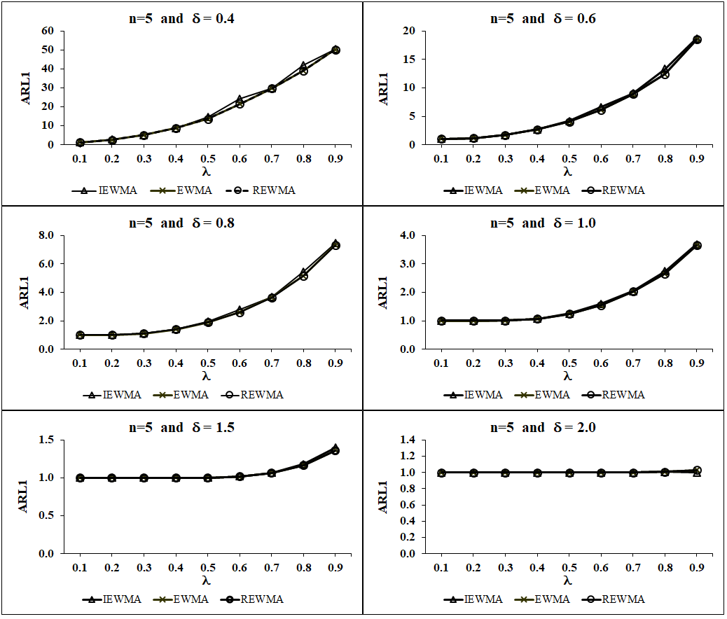

Figure 1: The out- of-control ARL1 of three control charts when calculating using the different values of and *n* equals 5 for data not contaminate outliers.

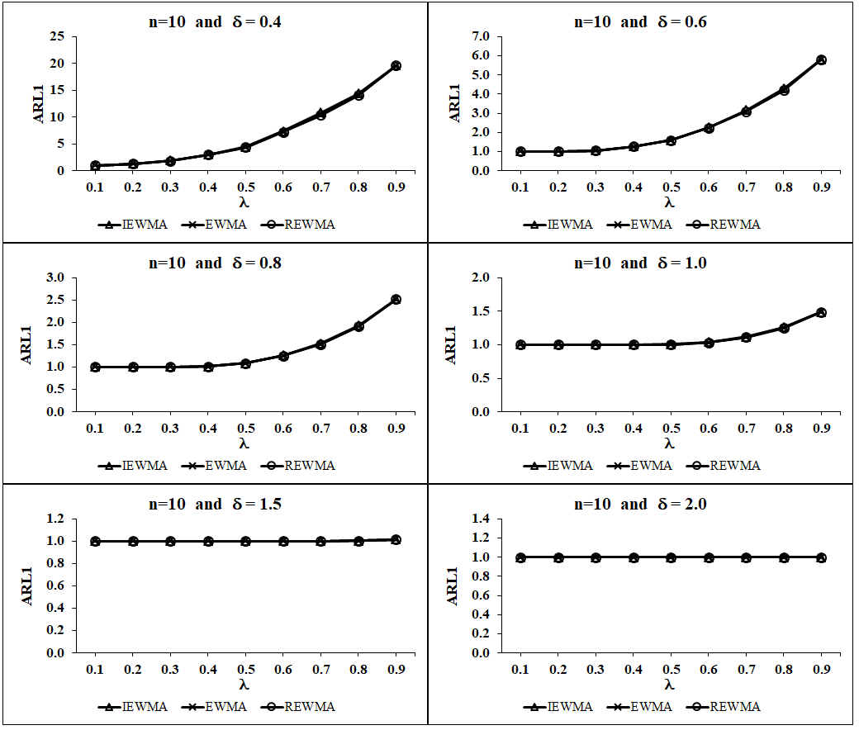

Figure 2: The out- of-control ARL1 of three control charts when calculating using the different values of and *n* equals 10 for data not contaminate outliers.

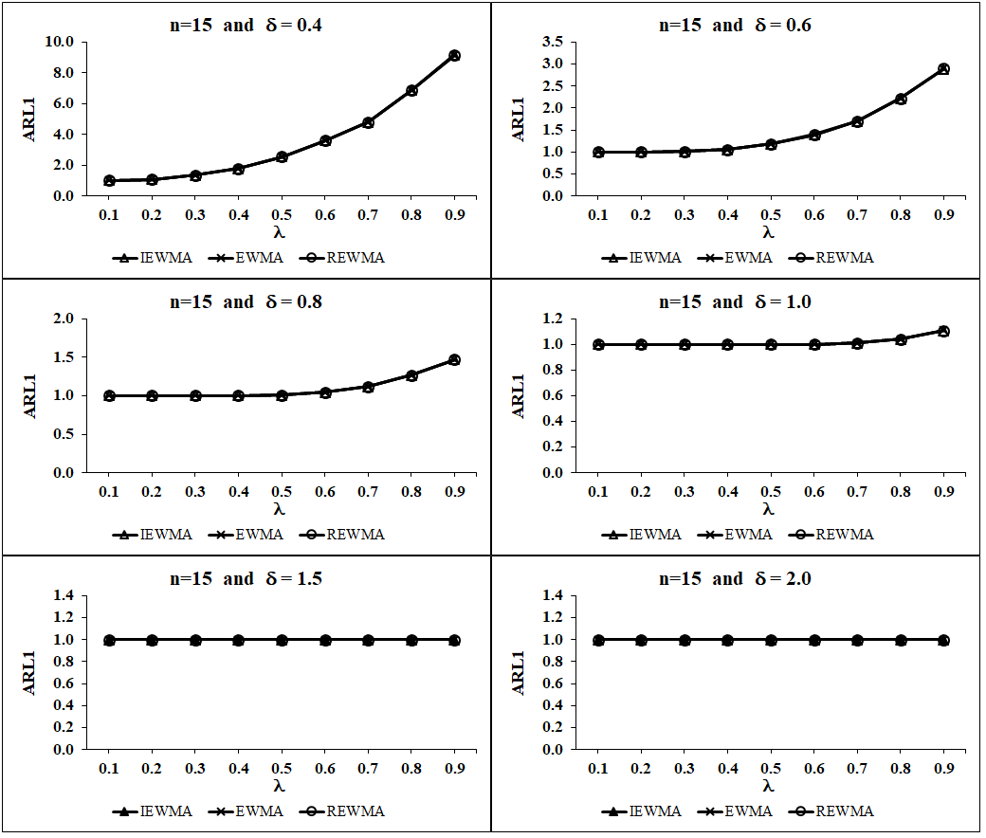

Figure 3: The out- of-control ARL1 of three control charts when calculating using the different values of and *n* equals 15 for data not contaminate outliers.

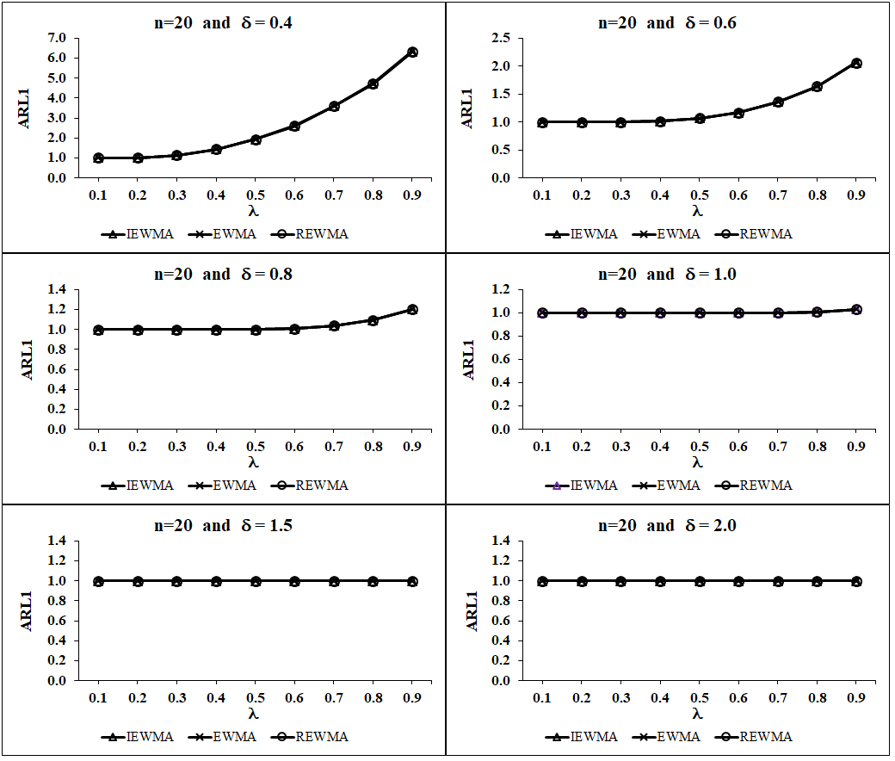

Figure 4: The out- of-control ARL1 of three control charts when calculating using the different values of and *n* equals 20 for data not contaminate outliers.

Table 2: ARL1 of five control charts when calculating using equals 0.1 for data not contaminate outliers

| n |  | Control charts | | | | |
| --- | --- | --- | --- | --- | --- | --- |
|  | IEWMA | EWMA | REWMA | MDMAD |
| 5 | 0.4 | 57.5 | 1.2* | 1.2* | 1.2* | 57.5 |
| 0.6 | 23.0 | 1.0* | 1.0* | 1.0* | 23.0 |
| 0.8 | 9.6 | 1.0* | 1.0* | 1.0* | 9.6 |
| 1.0 | 4.8 | 1.0* | 1.0* | 1.0* | 4.7 |
| 1.5 | 1.6 | 1.0* | 1.0* | 1.0* | 1.6 |
| 2.0 | 1.1 | 1.0* | 1.0* | 1.0* | 1.1 |
| 10 | 0.4 | 25.5 | 1.0* | 1.0* | 1.0* | 25.5 |
| 0.6 | 7.8 | 1.0* | 1.0* | 1.0* | 7.8 |
| 0.8 | 3.3 | 1.0* | 1.0* | 1.0* | 3.3 |
| 1.0 | 1.8 | 1.0* | 1.0* | 1.0* | 1.8 |
| 1.5 | 1.0* | 1.0* | 1.0* | 1.0* | 1.0* |
| 2.0 | 1.0* | 1.0* | 1.0* | 1.0* | 1.0* |
| 15 | 0.4 | 12.1 | 1.0* | 1.0* | 1.0* | 15.1 |
| 0.6 | 3.7 | 1.0* | 1.0* | 1.0* | 4.3 |
| 0.8 | 1.8 | 1.0* | 1.0* | 1.0* | 2.0 |
| 1.0 | 1.2 | 1.0* | 1.0* | 1.0* | 1.3 |
| 1.5 | 1.0* | 1.0* | 1.0* | 1.0* | 1.0* |
| 2.0 | 1.0* | 1.0* | 1.0* | 1.0* | 1.0* |
| 20 | 0.4 | 8.6 | 1.0* | 1.0* | 1.0* | 8.6 |
| 0.6 | 2.6 | 1.0* | 1.0* | 1.0* | 2.6 |
| 0.8 | 1.4 | 1.0* | 1.0* | 1.0* | 1.4 |
| 1.0 | 1.1 | 1.0* | 1.0* | 1.0* | 1.1 |
| 1.5 | 1.0* | 1.0* | 1.0* | 1.0* | 1.0* |
| 2.0 | 1.0* | 1.0* | 1.0* | 1.0* | 1.0* |

Note: * means that the control charts have the lowest ARL1 in that situation.

As a result of Table 2, it is found that the three control charts— IEWMA, EWMA and REWMA control charts (when using  equals 0.1)—have the lowest ARL1 , which is ARL1 mostly equals 1, for all levels of  and all levels of sample sizes. Furthermore, the MDMAD and average control charts tend to slowly detect the changes of process mean when the small process mean shifts from the target are occurred.

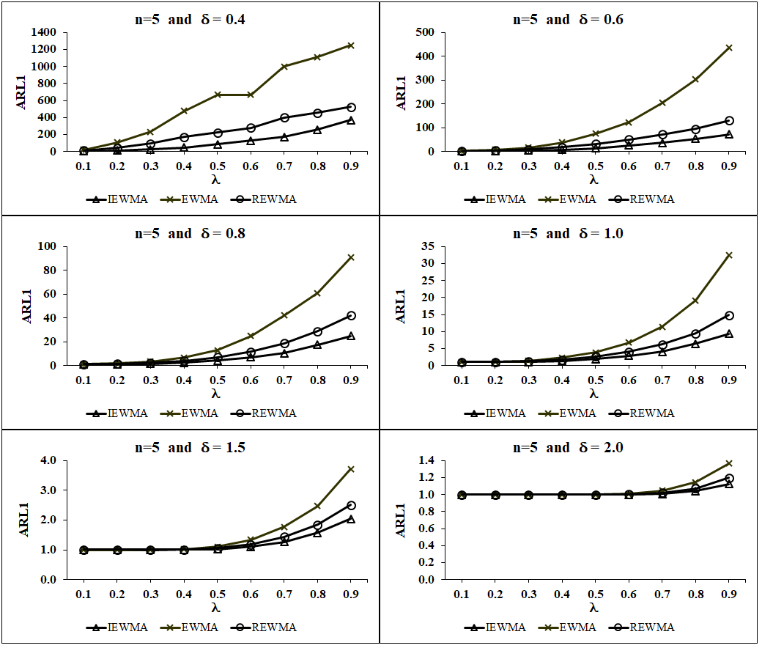

Figure 5: The out- of-control ARL1 of three control charts when calculating using the different values of and *n* equals 5 for data contaminate 5% outliers.

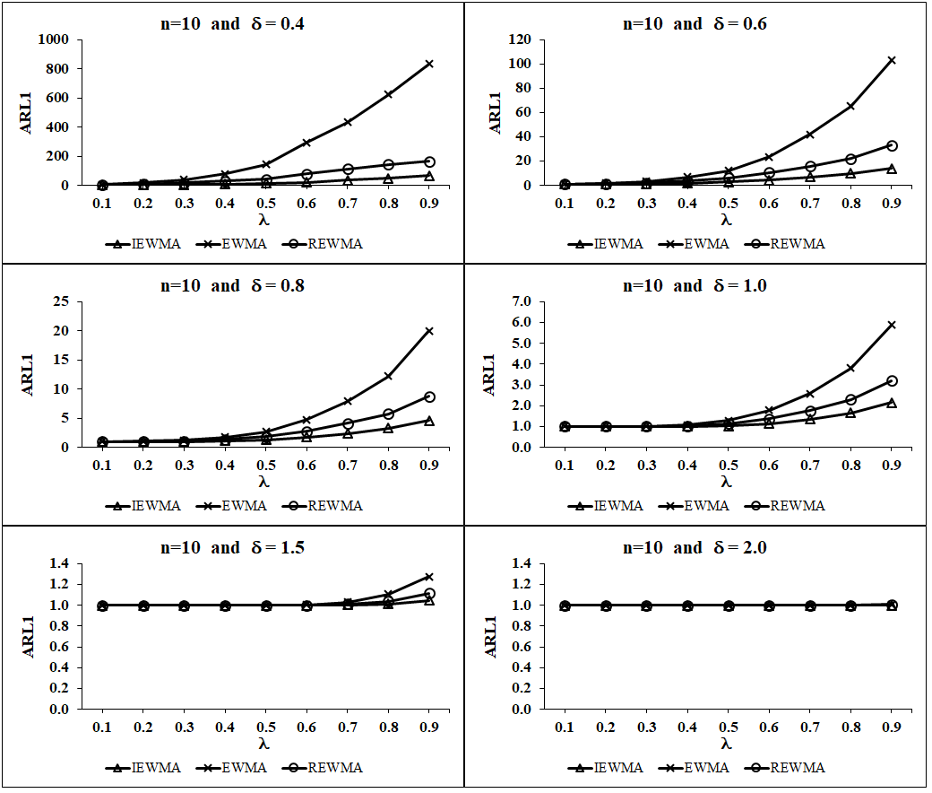

Figure 6: The out- of-control ARL1 of three control charts when calculating using the different values of and *n* equals 10 for data contaminate 5% outliers.

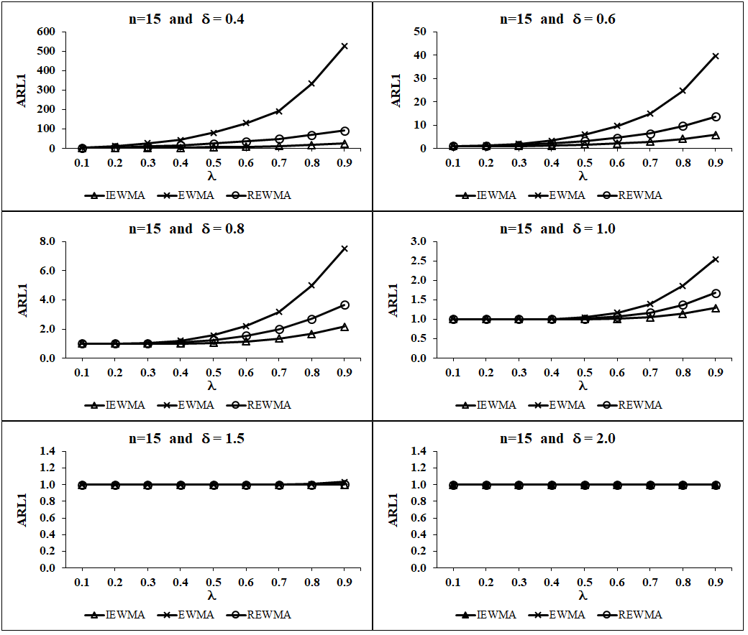

Figure 7: The out- of-control ARL1 of three control charts when calculating using the different values of and *n* equals 15 for data contaminate 5% outliers.

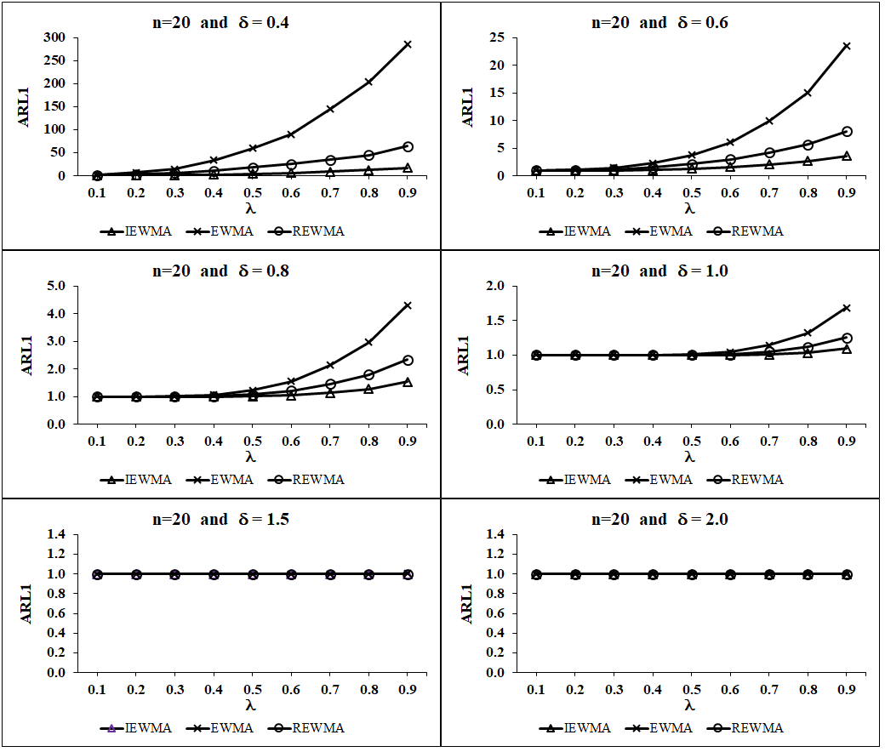

Figure 8: The out- of-control ARL1 of three control charts when calculating using the different values of and *n* equals 20 for data contaminate 5% outliers.

Figure 5 to Figure 8 show the results in case of control charts are created from the sample data set that are contaminated with 5% outliers of the total collected data. These Figures are also illustrated that the best value of constant  that makes the three control charts perform well is the same as case of data are not contaminated with outliers. That is,  equals 0.1 will make these charts have the smallest ARL1 for all sample sizes. Additionally, if the values of  increase, the efficiencies of these three charts seem to gradually detect the changes of process mean for the small shifts. These simulation study results are shown that if the process are massive changes, e.g. all values of  are suitable features to estimate the control limits because the expressions in term of ARL1 for the three charts are not different, especially for the larger sample sizes ( = 15, 20) in each subgroup. From Figure 5 to Figure 8, when using the values of  are greater than 0.1, that is the values of  equals 0.9, it is found that the ARL1 of IEWMA control chart tends to be smaller than those of EWMA and REWMA control charts for all levels of sample sizes, especially for the small changes in process mean from the target.

Table 3: ARL1 of five control charts when calculating using equals 0.1 for data contaminate 5% outliers

| n |  | Control charts | | | | |
| --- | --- | --- | --- | --- | --- | --- |
|  | IEWMA | EWMA | REWMA | MDMAD |
| 5 | 0.4 | 1,428.6 | 2.8* | 21.1 | 11.8 | 344.8 |
| 0.6 | 500.0 | 1.1* | 1.8 | 1.4 | 82.6 |
| 0.8 | 123.5 | 1.0* | 1.0* | 1.0* | 31.5 |
| 1.0 | 46.1 | 1.0* | 1.0* | 1.0* | 12.7 |
| 1.5 | 5.3 | 1.0* | 1.0* | 1.0* | 2.6 |
| 2.0 | 1.7 | 1.0* | 1.0* | 1.0* | 1.3 |
| 10 | 0.4 | 909.1 | 1.2* | 5.2 | 3.0 | 83.3 |
| 0.6 | 126.6 | 1.0* | 1.0* | 1.0* | 19.4 |
| 0.8 | 30.4 | 1.0* | 1.0* | 1.0* | 6.4 |
| 1.0 | 9.0 | 1.0* | 1.0* | 1.0* | 2.9 |
| 1.5 | 1.6 | 1.0* | 1.0* | 1.0* | 1.1 |
| 2.0 | 1.0* | 1.0* | 1.0* | 1.0* | 1.0* |
| 15 | 0.4 | 555.6 | 1.0* | 3.2 | 1.9 | 34.8 |
| 0.6 | 59.9 | 1.0* | 1.0* | 1.0* | 7.9 |
| 0.8 | 11.4 | 1.0* | 1.0* | 1.0* | 2.9 |
| 1.0 | 3.5 | 1.0* | 1.0* | 1.0* | 1.5 |
| 1.5 | 1.1 | 1.0* | 1.0* | 1.0* | 1.0* |
| 2.0 | 1.0* | 1.0* | 1.0* | 1.0* | 1.0* |
| 20 | 0.4 | 344.8 | 1.0* | 1.7 | 1.3 | 23.6 |
| 0.6 | 34.4 | 1.0* | 1.0* | 1.0* | 4.9 |
| 0.8 | 6.3 | 1.0* | 1.0* | 1.0* | 1.9 |
| 1.0 | 2.2 | 1.0* | 1.0* | 1.0* | 1.2 |
| 1.5 | 1.0* | 1.0* | 1.0* | 1.0* | 1.0* |
| 2.0 | 1.0* | 1.0* | 1.0* | 1.0* | 1.0* |

Note: * means that the control charts have the lowest ARL1 in that situation.

From Table 3, it is found that IEWMA control chart (for using  equals 0.1) have the lowest ARL1 for all levels of  regardless of the sample size. Further, the three charts with using  equals 0.1—IEWMA, EWMA and REWMA control charts—have the lowest ARL1 (it means that ARL1 equals 1) for the values of  that are greater than 0.6 and sample sizes in each subgroup equal 10, 15 and 20. Furthermore, the MDMAD and average control charts tend to slowly detect process abnormalities for the small shifts of process, these obviously found for the small sample sizes in each subgroup.

# Discussion

In case of control charts are created from the sample data without outliers, the simulation results show that the performance of exponentially weighted moving average control chart is better than the Shewhart average control chart for all situations. This conforms to the researches of (Huang, Tai and Lu, 2014) and (Chew *et al.*, 2015). This research is also found that REWMA control chart, which is constructed from the sample data that are contaminated with outliers, have a good efficiency in detection of process anomalies when process mean changes from the target as mention by (Khoo and Sim, 2006). Even though, the proposed control chart is estimated from data with outliers, it will rapid detection when process mean has slightly change from the target because the proposed control limits are derived by using two robust properties, i.e., the fast initial response feature (Lucas and Crosier, 1982; Lucas and Saccucci, 1990) and the robust point estimators of location and scale parameters (Hampel, 1974; Rousseeuw and Croux, 1993; Sinsomboonthong, Abu-Shawiesh and Kibria, 2020). These properties make the performance of IEWMA control chart superior to others.

# Conclusion

The proposed control chart or IEWMA control chart was developed from the exponentially weighted moving average control chart and applied the fast initial response feature that Lucas and Saccucci suggested (Lucas and Saccucci, 1990). In case of IEWMA control chart is constructed from the sample data that are not contaminated with outliers, its performance to detect about process mean shifts from the target tends to be close to exponentially weighted moving average control chart and REWMA control chart forall levels of the process mean shiftsregardless of the sample size. Additionally, if control limits of IEWMA control chart are constructed from the sample data that contaminate with 5% outliers of the total amount of the collected data, it also performs the most efficiency for process mean shifts detection for all sample sizes, especially for the small process mean shifts from the target.

# References

1. Abu-Shawiesh, M. O. A. (2009) ‘A control chart based on robust estimators for monitoring the process mean of a quality characteristic’, *International Journal of Quality and Reliability Management*, 26(5), pp. 480–496. doi: 10.1108/02656710910956201.
2. Chakraborti, S. and Graham, M. A. (2019) ‘Nonparametric (distribution-free) control charts: An updated overview and some results’, *Quality Engineering*, 31(4), pp. 523–544. doi: 10.1080/08982112.2018.1549330.
3. Chew, X. Y. *et al.* (2015) ‘The variable sampling interval run sum X control chart’, *Computers and Industrial Engineering*, 90, pp. 25–38. doi: 10.1016/j.cie.2015.08.015.
4. CRAMÉR, H. (1999) *Mathematical Methods of Statistics (PMS-9)*. Princeton University Press. Available at: http://www.jstor.org/stable/j.ctt1bpm9r4.
5. Montgomery, D.C. (2012) *Introduction to Statistical Quality Control*. John Wiley&Son.
6. Hampel, F. R. (1974) ‘The influence curve and its role in robust estimation’, *Journal of the American Statistical Association*, 69(346), pp. 383–393. doi: 10.1080/01621459.1974.10482962.
7. Hesamian, G., Akbari, M. G. and Ranjbar, E. (2019) ‘Exponentially Weighted Moving Average Control Chart Based on Normal Fuzzy Random Variables’, *International Journal of Fuzzy Systems*, 21(4), pp. 1187–1195. doi: 10.1007/s40815-019-00610-4.
8. Huang, C. J., Tai, S. H. and Lu, S. L. (2014) ‘Measuring the performance improvement of a double generally weighted moving average control chart’, *Expert Systems with Applications*, 41(7), pp. 3313–3322. doi: 10.1016/j.eswa.2013.11.023.
9. Khoo, M. B. C. and Sim, S. Y. (2006) ‘A robust exponentially weighted moving average control chart for the process mean’, *Journal of Modern Applied Statistical Methods*, 5(2), pp. 464–474. doi: 10.22237/jmasm/1162354800.
10. Lucas, J. M. (1982) ‘Combined Shewhart-CUSUM quality control schemes’, *Journal of Quality Technology*, 14(2), pp. 51–59.
11. Lucas, J. M. and Crosier, R. B. (1982) ‘Fast initial response for CUSUM Quality-control schemes: Give your CUSUM A head start’, *Technometrics*, 24(3), pp. 199–205. doi: 10.1080/00401706.2000.10485987
12. Lucas, J. M. and Saccucci, M. S. (1990) ‘Exponentially weighted moving average control schemes: Properties and enhancements’, *Technometrics*, 32(1), pp. 1–12. doi: 10.1080/00401706.1990.10484583.
13. Mitra, A., Lee, K. B. and Chakraborti, S. (2019) ‘An adaptive exponentially weighted moving average-type control chart to monitor the process mean’, *European Journal of Operational Research*, 279(3), pp. 902–911. doi: 10.1016/j.ejor.2019.07.002.
14. Reynolds, J. H. (1971) ‘The run sum control chart procedure’, *Journal of Quality Technology*, 3(1), pp. 23–27.
15. Roberts, S. W. (2000) ‘Control chart tests based on geometric moving averages’, *Technometrics*, 42(1), pp. 97–101. doi: 10.1080/00401706.2000.10485986.
16. Rocke, D. M. (1992) ‘XQ and XR charts: Robust control charts’, *The Statistician*, 41, pp. 97–104.
17. Rousseeuw, P. J. and Croux, C. (1993) ‘Alternatives to the median absolute deviation’, *Journal of the American Statistical Association*, 88(424), pp. 1273–1283. doi: 10.1080/01621459.1993.10476408.
18. Knoth, S. (2005) ‘Fast initial response features for EWMA control charts’, *Statistical Papers*, 46, pp. 47–64.
19. Rigdon, S.E. and Champ, C.W. (1997) ‘An analysis of RUNSUM control chart’, *Journal of Quality Technology*, 29, pp. 407–417.
20. Şentürk, S. *et al.* (2014) ‘Fuzzy exponentially weighted moving average control chart for univariate data with a real case application’, *Applied Soft Computing Journal*, 22, pp. 1–10. doi: 10.1016/j.asoc.2014.04.022.
21. Shamsuzzaman, M. and Wu, Z. (2012) ‘Design of EWMA control chart for minimizing the proportion of defective units’, *International Journal of Quality and Reliability Management*, 29(8), pp. 953–969. doi: 10.1108/02656711211270379.
22. Sinsomboonthong, J., Abu-Shawiesh, M. O. A. and Kibria, B. M. G. (2020) ‘Performance of robust confidence intervals for estimating population mean under both non-normality and in presence of outliers’, *Advances in Science, Technology and Engineering Systems*, 5(3), pp. 442–449. doi: 10.25046/aj050355.
23. Steiner, S. H. (1999) ‘EWMA control charts with time-varying control limits and fast initial response’, *Journal of Quality Technology*, 31(1), pp. 75–86. doi: 10.1080/00224065.1999.11979899.
24. Walker, A. M. (1968) ‘A Note on the Asymptotic Distribution of Sample Quantiles’, *Journal of the Royal Statistical Society: Series B (Methodological)*, 30(3), pp. 570–575. doi: 10.1111/j.2517-6161.1968.tb00757.x.
25. Wang, H. (2009) ‘Comparison of p control charts for low defective rate’, *Computational Statistics and Data Analysis*, 53(12), pp. 4210–4220. doi: 10.1016/j.csda.2009.05.024.

I